BACP accreditation is:

‘A quality standard for the experienced practitioner who can demonstrate high standards of competent and ethical practice’

SCoPEd transition period: An application guide for BACP’s individual accreditation scheme (column B)

Contents
Completing the Application Form 3
Part A: Personal Information 3
Your details 3
Eligibility criteria 4
Complaints and refusals 4
Part B – Current practice overview 5
Diary of current practice 6
Part C and D: Training requirements 8
Part C: if your training was BACP accredited or approved 9
Part D: if your training wasn’t BACP accredited or approved 10
Part E - Practice Hours 12
Part F - Supervision 13
Part G - Reflective Practice Criteria 1 & 2 15
Reflective Practice Criteria 16
Making an application from outside the UK 24
Paying for your Application 24
Honesty and plagiarism 24
Further information and advice 25
Processing your application 26
Getting your result 27
How to contact us 27

Completing the Application Form
This guidance document is for current registered members applying for individual accreditation (column B) during the SCoPEd transition period. It provides additional information and clarification on some of the common queries we receive. It also provides clarification on key points to help you understand what’s required and submit correct information.

Part A: Personal Information

Your details
Please check that we have your correct contact details, as we may need to email you with any queries or to provide an update on your application.

Eligibility for Application

You can apply for individual accreditation once you’ve achieved BACP registered member status and when you believe you meet all the criteria when the transition period opens in early February 2024. You’ll need to demonstrate a combination of training, client hours and reflective practice.

You don’t have to apply by a specific deadline – your training doesn’t ‘run-out’ or ‘expire’.

Eligibility criteria
a | Be a registered member of BACP
b | Be practising as a counsellor and/or psychotherapist. You must have been in practice for at least three years when you apply for accreditation.
c | Have undertaken training as follows:  c.1 Been awarded a qualification from a BACP accredited training course  or  c.2 Successfully completed and received an award for practitioner training that:  - Included at least 450 hours of tutor contact hours  - Was carried out over at least two years (part-time) or one year (full-time)  - Had a supervised placement as an integral part of the training  - Covered theory, skills, professional issues and personal development
d | Have at least 450 hours of supervised practice accumulated within three to six years (they don’t have to be consecutive years). Of the 450 hours, at least 150 hours of supervised practice must be after the successful completion of your BACP accredited course or practitioner training, which are calculated from the date on the award certificate.
e | Have an ongoing current contract for counselling/psychotherapy supervision for a minimum of 1½ hours per month. Have been supervised for at least 1½ hours per month throughout the period of practice submitted.

Complaints and refusals
Your BACP registered membership must be paid and up to date or a current direct debit must be in place for the duration of your application. If a payment has failed, you haven’t paid, or your registration is not current, your application will not be processed until this is resolved.

If you’re the subject of a complaint in relation to your work as a counsellor/psychotherapist or in another role that might have a bearing on this work, you should tell us about this. It doesn’t t automatically mean that your application can’t be processed but we’d would need to consider it carefully.

We’d like to remind you that as a registered member of BACP you sign to agree to abide by our Ethical Framework.

Part B – Current practice overview
In this section, you’ll need to tell us about your general current practice – this is the range of clients (e.g. individual adults, children and young people, couples, groups) that you’d usually work with and the different methods by which you offer sessions (e.g. face-to-face, online or by phone), as well as if your practice includes work with clients based in other countries (outside the UK).

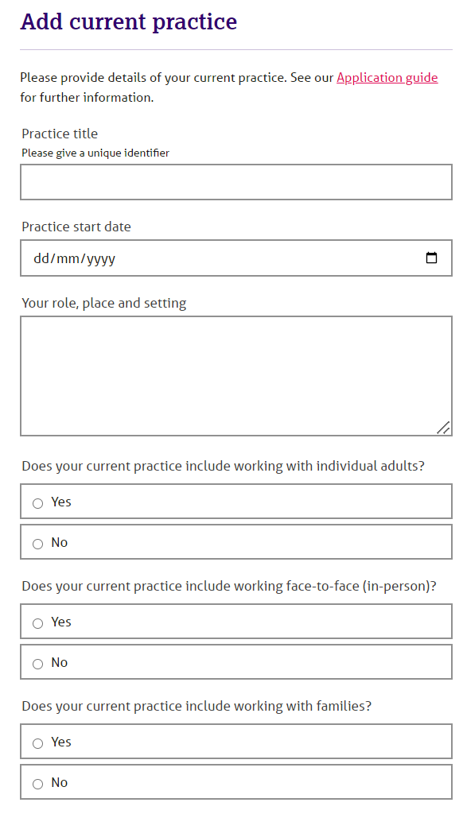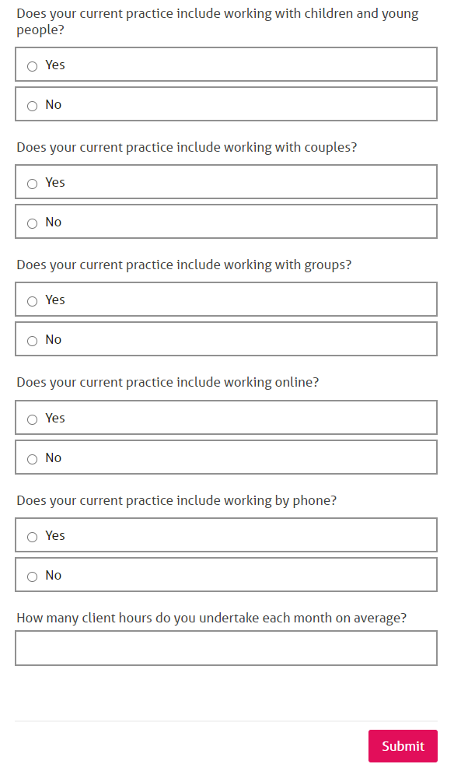
The number of clients you see each month must be similar to the number of completed sessions you submit for the diary and show all client types you work with. Please only include your current practice setting/s in this section.

Diary of current practice
In the blank tables provided, please give details of your work with clients over the past two weeks. (If you can’t use the last two weeks for any reason, use a two week period from the past six months.) The hours of counselling/psychotherapy work you use in your application shouldn’t include assessment interviews, training sessions, supervision, cancelled or missed sessions (Could or Did Not Attend or CNA/DNA).

If you’ve declared that you practice in more than one setting, please show the sessions for each type of work setting and keep all sessions from the same setting together in the same table. Don’t give clients’ names. Give each client a reference letter or number and age in brackets. For example, for a client aged 45 and referred to as client A, enter A (45).

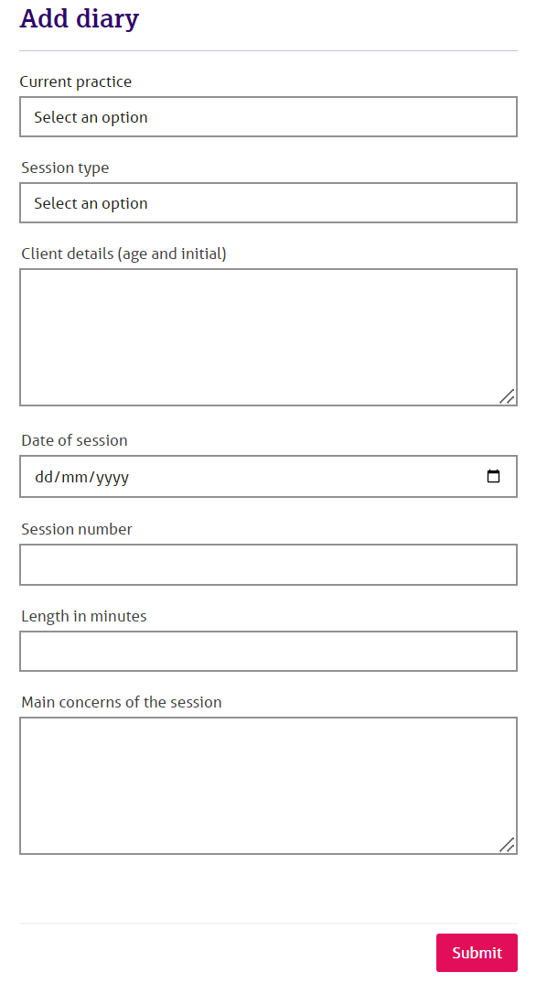
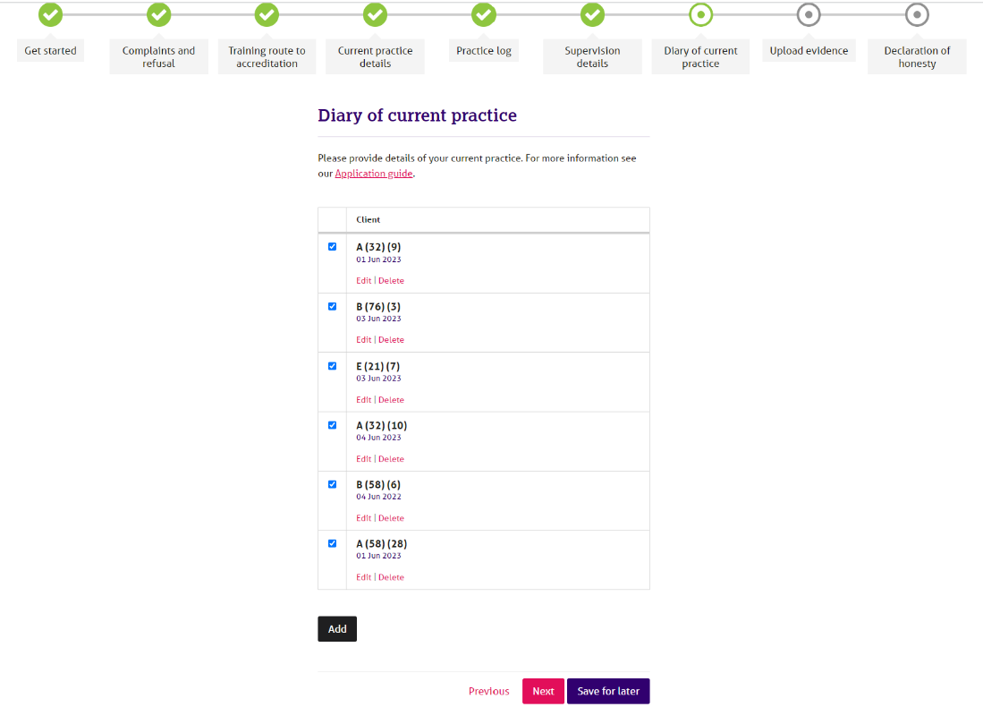

Part C and D: Training requirements
Individual accreditation routes are slightly different for those who have completed either a BACP accredited training or BACP approved qualification (Part C), and those whose training was not BACP affiliated in either of these ways (Part D). Please see general guidance on training below, and then specific information on these routes below.

Completion of award
Whether you apply under Part C or Part D, all the courses you include in your application must be completed – you must have passed and been given the award. Certificates of attendance, achievement or completion are not sufficient, and courses where there was no assessment of your competence at the end are also not eligible. You can’t use part completed courses either – for example one year of a degree course. We don’t operate a ‘credits’ system.

Name changes
If your name on our records is different from that on your certificates you’ll also need to send us formal evidence of that change, such as marriage/civil partnership certificate or deed poll, if this information hasn’t been previously submitted.

Part C: if your training was BACP accredited or approved

If your training was BACP accredited or approved you’ll be able to select your course from the menu in the online form.

BACP approved qualifications and supplementary training courses

If your training was a BACP approved qualification that included less than 450 guided learning hours, you can supplement your approved qualification training with another training course, if necessary, to meet the 450 guided learning hours requirement.

If you’re submitting more than one course as evidence of your training, there needs to be clear progression from one course to the next. A typical example might be a Certificate level course combined with a Diploma level course. Providing all the criteria are met when the courses are considered overall, you can use these. Combinations of short courses which don’t demonstrate coherent training, assessment and progression won’t meet the eligibility criteria.

If you’re unsure, please contact the BACP accreditation team at accreditation@bacp.co.uk

Part D: if your training wasn’t BACP accredited or approved

You need to demonstrate that you’ve undertaken counselling or psychotherapy core practitioner training. Training in other areas such as coaching, psychological wellbeing practitioner, psychology, social work, nursing, HR, hypnotherapy, NLP, religious ministry and alternative health therapies aren’t eligible. This list is not exhaustive.

Training in supervision can’t be included.

Distance or on-line only courses aren’t eligible. Eligible trainings must include face-to-face and synchronous (live) online taught sessions, with a maximum of 30% of the total tutor contact time delivered online.

If you're not sure your course meets BACP requirements for in-person and online teaching delivery, please visit our website for more information.

Supplementary training courses
If you’re using non-accredited training courses to apply under Part D you can supplement your core training with another training course, if necessary, to meet the 450 guided learning hours requirement. If you’re submitting more than one course as evidence of your training, there needs to be clear progression from one course to the next. A typical example might be a Certificate level course combined with a Diploma level course. Providing all the criteria are met when the courses are considered overall, you can use these. Combinations of short courses which don’t demonstrate coherent training, assessment and progression won’t meet the eligibility criteria.

If you’re unsure, please contact the BACP accreditation team at accreditation@bacp.co.uk

Placement and supervision requirements
You must have had a supervised and assessed integral placement on at least one of the courses you use for your application. By this we mean assessed and supervised counselling/psychotherapy work, with genuine clients (not with other students) carried out as part of your course and which you were required to successfully pass in order to graduate from that course. Your training must have included a supervised placement as an integral part of your course. You must be able to give details of this placement. You shouldn’t count your placement hours in the total formal taught contact hours given for the course.

Guided learning hours (GLH) definition
GLH time can include
- tutor-led lectures, tutorials and *facilitated study
- directed assignments
- skills practice sessions
- discussion groups
- experiential groups

*Facilitated study could include:
- tutor guidance for students in open learning centres
- tutor-facilitated research or research awareness
- learning workshops
- web-based tutorials

We don’t mean private individual or group study, research, writing assignments or placements or supervision.

The training you provide details of in this section doesn’t need to have been undertaken all on one course, although there must be clear evidence of practitioner training in counselling/psychotherapy. Please click ‘add’ for each course you want to give details of, starting with the most substantial course(s). You can only use courses that you’ve successfully completed and for which you’ve received the award certificate.

You must show how the course covered the following elements:
- theory
- skills
- professional issues
- personal development

If you’ve an official breakdown of the course hours and elements from your training institution, you can send this, providing the breakdown is clearly shown.

Please check with the accreditation team that we have a copy of your award certificate/s on file. If we don’t, you’ll need to include copies of the relevant certificates with your submission.

Part E - Practice Hours
‘Counselling’ and ‘Psychotherapy’ are umbrella terms covering a range of talking therapies delivered by professionally trained and qualified practitioners within a context of confidentiality and clear ethical boundaries.

Therapeutic work may be short or long term and is respectful of the clients’ wishes, supporting them as they identify their own goals, come to their own conclusions and reach their own decisions.

You can use any practice towards your application providing it meets the description above and is supervised to the required level. Helpline or counselling skills work is not suitable for this accreditation scheme. Members working as Psychological Wellbeing Practitioners (PWPs), Mental Health Mentors, or in roles offering coaching or guided self-help should be aware that this work is not eligible.

You can use paid or voluntary work, face to face, telephone or on-line counselling. Text-based online counselling is not eligible for inclusion. You can use work with adults, couples, groups (to include families) or children and young people.

You must be in practice when you apply. This means you must be seeing at the very least, one client on a regular basis. You need to have been in practice for a minimum of three years when you apply. You can start counting this three-year period from when you see your first client, which may allow you to include your placement as a student.

We require you to demonstrate a minimum of 450 supervised practice hours, over a period of three to six years (these don’t have to be consecutive years), of which at least 150 hours must be counted after you have successfully completed all your submitted counselling/psychotherapy training. Your post training practice will start after the date on your last training certificate submitted as part of your application.

Please include all your settings for each year you choose to submit.

If your sessions are 50 minutes, then you can claim a ‘therapeutic hour’. If your sessions are shorter or longer than this, then you should count the actual time the sessions are scheduled for.

Here is an example of the completed online table:

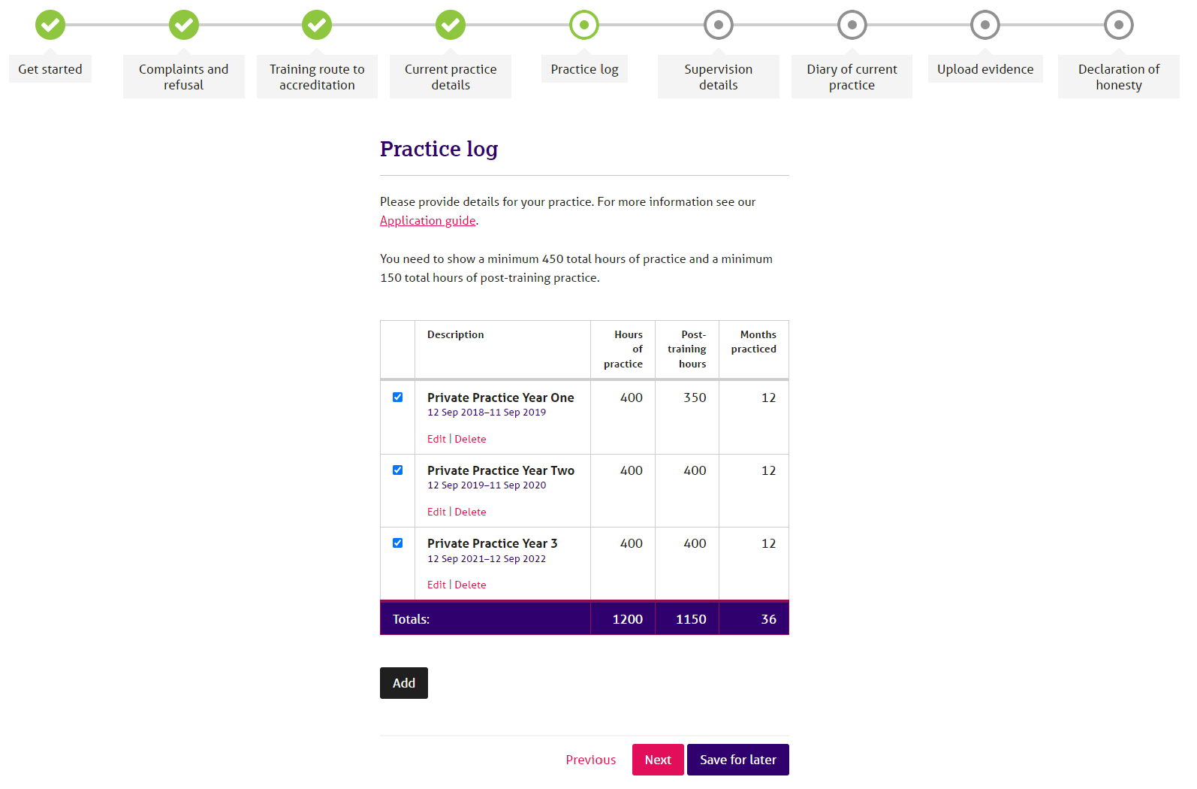

Part F - Supervision
You must be able to show a minimum of 1½ hours of supervision per month for ALL the practice that you include in Part E and your most recent or current arrangement.

You must not average supervision out across the year to meet the requirement. For this reason, arrangements such as one hour every three weeks or two hours every six weeks won’t meet the requirement, unless combined with another supervision arrangement.

If you work in more than one context or setting, e.g. Clinic, private practice, school, etc. each context or setting must be supervised separately, but you don’t need to have 1½ hours for each context.

You can use face-to-face, phone or on-line supervision. Text-based supervision is not allowed for accreditation purposes.
The BACP Supervision webpages offer comprehensive guidance regarding supervision requirements for accredited members along with links to BACP good practice in action guidance

- If you’re using text-based supervision (synchronous and asynchronous) because you're delivering text-based therapy this won’t count towards your monthly supervision time and should be in addition to the arrangements you have for individual or group supervision that is face-to-face, online or video, or over the phone.

You can combine individual, group and peer supervision to meet the minimum requirement. However, remember that there is a formula for working out how much time you can claim for group and peer supervision:

- Don’t count the ‘facilitator’ or ‘group supervisor’ for group supervision. For peer supervision groups, count all members of the group.

- If you’re in a group of four supervisees or less, claim half of the time.

- If you’re in a group of five supervisees or more, divide the number of hours by the number in the group and claim the resulting time.

We appreciate that some sessions may be missed due to holiday or sickness but remember that the contract must remain in place. If more than one session in a row is likely to be missed, you should consider putting in place new or temporary arrangements. Ad-hoc arrangements cannot be included.

Ideally, your supervisor will have undertaken supervision training however, this isn’t a requirement. In addition, they don’t need to be a registered or accredited member of BACP, but they should be a member of an equivalent professional body that has an ethical code and complaints procedure. We do expect your supervisor to be adequately qualified and/or experienced as a counsellor/psychotherapist to supervise your work.

If your supervisor is also your line manager, or if there is another type of dual relationship, you must be able to demonstrate that you have an arrangement in place for other independent consultation. Simply declaring that you understand the dual relationship exists isn’t sufficient.

You should look specifically at the Ethical Framework regarding supervision.

Further guidance about supervision, including dual relationships can be found in our Good Practice in Action resources, available on the ‘Ethics and Standards’ section of the website.

This part of the application has separate sections for individual, group and peer supervision.

Please complete a section for:

- each supervision arrangement for the practice hours shown in your practice diary
- each supervision arrangement for your current and ongoing work and is in addition to your supervisor’s statement

If you have more than one arrangement with the same supervisor (for example, you have the same supervisor for individual supervision and group supervision), you must complete a separate section for each different arrangement or for any amendments to your contract.

Part G - Reflective Practice Criteria 1 & 2
There’s a specific word count for each criterion, and this is clearly marked on the application form. It’s important that you make sure your work stays within this word count. If your work is over this amount we’ll ask you to do it again. Include total word count at the end of each criterion.

There’s no minimum word count but make sure you have adequately addressed all the criteria to give yourself the best chance of being successful.

Everything you want assessed should be within the main piece of work. Don’t include appendices to your work – these won’t be assessed.

You must show the assessors where you meet each sub-criterion. You can use brackets within the text, section headings or numbers in the margins.

We don’t expect you to write academic style essays but do properly reference any quotes or books/articles you refer to in your work.

Reflective Practice Criteria
Criterion 1: Current way of working (up to 2,500 words)

This part is about your current way of working with the clients presented in your diary of practice. You need to include details for each of the sub-criterion. You should describe in your own words what you do and why you do it, with all your different client groups.

Criterion 1: General Guidance
For this criterion you need to show a clear link between your way of working and the theory or theories that inform your approach. You should explain the theory to show your conceptual understanding but you don't need to give a lengthy account. We understand the theories and concepts, so we want you to show your understanding and tell us about how and why you're using these approaches rather than the theory itself.

If you use different approaches, explain how you bring these together to form a consistent way of working. Consider the different theories that underpin these concepts and how they sit together with your main theoretical base. Explain what prompts your use of interventions from these different approaches and how you bring them together into a coherent approach.

For example, if you say ‘my core approach is person-centred but I also use CBT techniques when appropriate’, that doesn't tell us how you bring these two very different approaches together to make a coherent whole, or what ‘when appropriate’ actually means.

Or if you have a ‘toolkit’ of different techniques and approaches, you need to tell us what these are, what theories underpin them and why you might use them. It's important to show how you reconcile any differences and your rationale for using a particular approach or intervention.

It may help to list the different words connected to your way of working – such as core conditions, self-actualisation, non-directive, transference, scaling, parent, adult, child, negative automatic thoughts, maintenance cycle.

Using theory words and jargon is only useful if their meaning is clear. You don’t need to include quotes from literature sources or provide a bibliography.

Consider all the different client groups you work with
If you work with individual adults and with children and young people, if you see couples, families and groups, or if you practise in both short and long-term settings, your way of working is likely to differ to fit the needs of these different groups. Tell us how you adapt your approach and any particular considerations that affect your way of working with them.

For example, when working with children and young people, different developmental stages may inform your approach or use of interventions.

Think about your additional ways of working
If you've answered yes to working in a specific way, such as working online or by phone, or your practice includes work with clients who are outside the UK, explain what impact the context or setting may have on your way of working and how you’ve adapted your approach to work in this way. If any of your clients are overseas, you’ll also need to address any special considerations when working with clients across international borders.

For example, have you undertaken any training or CPD to assist with this work. What additional factors, such as confidentiality and disinhibition, do you need to consider? Do you discuss these with your client?

You may find it helpful to describe your client groups and explain your ways of working to a colleague. They can help you articulate your approach by prompting you and asking questions. Talking into a recording device may also help in the early stages of writing.

Focus on how you work now
When you've been qualified for some time, your approach is likely to have developed through your experience, CPD and additional training. So, while your past training is relevant and important, we're most interested in how you practise today. You may have trained and work within one theoretical orientation, or your practice may incorporate several different approaches. Your rationale – and your way of working - is unique to you.

You don’t need to tell us about theories or ways of working that you no longer use. For example, if you worked with children 10 years ago but no longer work in this way, there’s no need to say you work with children and young people or to explain how you work with them.

The word count given is for the whole criterion and your writing must include information to cover all the sub-criteria. You can approach this in the way you find easiest. For example, you may want to use headings to address each sub-criterion in turn or write one piece with each sub-criterion woven in and clearly referenced in the body of the text using parentheses e.g. (1.i) etc.

There is additional guidance for each sub-criterion below – please read this carefully and ensure you understand what each one is asking for.

Describe and explain your current way of working and how it has evolved over time. You’ll need to address each of the following five points:

i. The theory or theories and approaches that you draw on in your work, and how you bring them together. This should include references to your core training as well as any subsequent training/CPD you have undertaken that have influenced your way of working

This part is about the knowledge used that informs your practice with clients. It incorporates your understanding and use of theory/theories and on what basis you integrate different theory/theories with clients in a meaningful way.

We don’t require you to explain main theories and concepts in detail as all assessors are trained/practicing therapists across a range of modalities. However, please explain any uncommon abbreviations or acronyms specific to your way of working or place of work.

ii. The different types of interventions and/or responses you use and why

This part is about how you work with your clients, what you do in response to different client presentations, and why you use these approaches, interventions and/or responses.

iii. The role of your reflective self-awareness in your way of working

This sub-criterion should describe how you understand the role of your reflective self-awareness in relation to the therapy process. How you address this is likely to depend on your modality, approach and the theory or theories that underpin your current practice.

You should explain how you use yourself within the therapeutic relationship. Show your awareness of your own process and describe how you work safely without your own reactions and experiences getting in the way.

You can use specific terms relating to self-awareness that are consistent with your theoretical approach, such as congruence, immediacy, reflexivity, projection, transference and countertransference. You might use these words to describe the nature and importance of your self-awareness and how you observe and understand your use of self during the therapeutic process.

For example, you might use your reflective self-awareness when you work with enhanced empathy and ‘out of awareness’ processes, or with the dynamic unconscious through transference and countertransference.

When we use the words, ‘out of awareness’ or ‘unconscious’ we’re referring to something that is not at the forefront of the mind. For example, someone may be unaware of the cause of their issue when asked explicitly, but the cause may be found by exploration in therapy.

The terms ‘conscious’ and ‘unconscious’ as well as the terms ‘in awareness’ and ‘out of awareness’ are offered to be as inclusive as possible.

This list isn’t prescriptive and you don't have to use such terms. We're interested in how you see the role of your own self-awareness in your way of working in your own words.

iv. The impact of issues of difference and equality on your therapeutic relationships and how you work with these

This section requires a description of how you understand the impact of difference and equality on therapeutic work, and how you account for these in your practice. You might want to consider how this area was approached in your counsellor training and whether your understanding has developed or changed since qualification. You might also want to describe any understandings related to the modality you trained in, or how you understand your own positionality as a counsellor in relation to equality, diversity and inclusion (EDI).

In this sub-criterion we’re asking you to show your general understanding of how issues of difference and equality can affect your relationship with all your clients.

To meet this criterion, you need to show your awareness of these issues in relation to all your clients. We’re not looking for an example of work you did with a client who was different to you, a list of different issues, or statements like ‘I have lots of experience of working with difference’ or ‘I treat everyone the same’.

You need to explain how you address both explicit and implicit issues of difference and equality in your work, particularly those that are relevant to your area of practice.

For example, some issues are visible such as age, gender, race and physical disability. Others may be audible, like language, or perhaps invisible in the case of social class or religion. You may also wish to consider issues such as white privilege or neurodiversity.

You might consider the balance of power in the counselling relationship and how you seek to address this. This could include how clients see themselves in relation to the world and to you. You might also consider the similarities between yourself and your clients, for example your own belief systems, culture or social class, and how you guard against over identification.

Consider all the different client groups you practise with and the different contexts or settings in which counselling takes place. For example, a middle-class female counsellor who works with predominately male children within a deprived area may pay particular attention to age, gender, language, class, socio-economic factors and culture, and to how these issues can potentially impact or influence the therapeutic relationship.

Areas you choose to cover should demonstrate your ability to work with issues of power and authority, as experienced in unconscious or ‘out of awareness’ elements in the therapeutic relationship. You may also want to demonstrate your ability to critically explore your own identity, cultural positioning, values and worldview and how these could impact and/or influence your therapeutic practice.

v. How you adapt your approach and why when considering the following:

a. the setting(s) that you work in

This section should include information relating to all settings you included in Part B, for example in private practice, the NHS, educational settings, GP surgery etc. as well as how you adapt your approach for each context.

b. the modes of delivery for therapy (for example, face-to-face, online, phone)

This section should include details of all the modes of delivery you use in your current practice included in Part B, and how you have prepared for and adapt your approach for each.

c. the different client groups that you work with (for example, individuals, couples, CYP, families, groups, clients based outside of the U.K. etc.)

This section should include details of all the client groups you currently work with, included in Part B, and how you adapt your approach for each.

Remember that you must show the assessors how you meet these sub-criteria in relation to ALL the areas and client groups with which you currently work.

d. different client presentations, issues, and concerns

This section should include details of how you adapt your approach to account for different client presentations, issues and concerns.

Criterion 2: Case material (up to 3,000 words)

This criterion requires you to present case material showing how you use the approach you’ve described in Criterion 1 in your practice. You can write about your work with a single client or with two clients. You must use your case material to demonstrate your way of working (as described in Criterion 1) in practice.

All the interventions and approaches you describe in your case material for Criterion 2 must be included in and be consistent with your described way of working in Criterion 1.

Your case material should cover the following five points:

- Examples of the types of interventions and/or responses that you used, including why you used them and the impact this had on the client, the therapeutic relationship, and the therapeutic process

This sub-criterion is about how you practise. Your case material should demonstrate the way of working described previously under Criterion 1.i.

- Your awareness of the issues of difference and equality present in the relationship with your client, the impact these issues had on the therapeutic relationship and how you worked with these in the process with your client
This point refers to your awareness of issues of difference and equality as they presented in the relationship with your client, and the impact and approach chosen to address these. You need to use a specific example from your client work that illustrates the understanding and approach previously described in criterion 1.iv.

- How you used self-reflection and self-awareness in the therapeutic process and relationship with your client
To cover this point, your case material must illustrate your own self-awareness as a practitioner and how you use this awareness of self in the therapeutic relationship with your client or clients. As previously, this should be a specific example that demonstrates your ability to use self-reflection and self-awareness to develop the therapeutic relationship and process.

- How you worked through an ethical consideration or issue using the Ethical Framework. You’ll need to describe the situation making reference to the specific elements of the Ethical Framework that informed your ethical decision-making process
To cover this sub-criterion adequately your case material needs to show that you work within BACP’s Ethical Framework for the Counselling Professions and are able to use this appropriately in your therapeutic work. You need to give specific illustrations of how you have used the framework when working through an ethical issue in your practice, rather than make general points about contracting or maintaining confidentiality etc.

- How you used supervision for the benefit of this client work. You’ll need to include the learning and awareness that you gained from supervision and how you subsequently applied this in the client work being used for your case material
To cover this point your case material should also show what you’ve learned and how you’ve gained awareness through your supervision and illustrate how you’ve applied this in your work with the client you’re using for the case material in Criterion 2.

You can write about one or two clients but no more than this. The client work doesn’t have to be ongoing, but if it’s finished, it should have ended no more than six months before you apply. Whichever client or clients you choose to write about, they should be typical of your current work as described elsewhere in your application.

Make sure the client can’t be identified from what you write but you don’t need to send written permission from the client with your application.

We do appreciate that you may have written a case study for another purpose, such as a course and want to use this. Remember that it’s important you demonstrate that you can meet the accreditation criteria. Case studies written for other purposes might not necessarily help you to do this – even if you chose the same client(s) you may need to significantly re-write the work in order to be successful.

All case material submitted should be commented on by your supervisor(s) in their supervisor statement.

The case material should illustrate self-reflection, give a sense of the relationship between you and your client or clients and show that the way of working described in Criterion 1 is consistent with the approach you used with your client or clients for the criterion 2 case material . It shouldn’t be an account of the client’s story or a chronicle of events, but it can include extracts from client sessions.

You don’t have to present the case material as an academic essay; you may use headed paragraphs, bullet points, margin notes or a similar method for clarification. You don’t need to fully reference published work, authors, theories etc. unless you are quoting directly from someone’s work.

Further guidance on Criterion 2 can be found on our website.

Supervisor’s statement
You need to include a statement from the supervisor who supervised your case material (reflective practice Criterion 2). As this scheme is aligned with SCoPEd column B competences, your supervisor should be familiar with the SCoPEd framework and able to comment on your practice in reference to the framework.

There’s a separate form for this statement available on our website. This form must be sent to your supervisor for completion. This form must be written by your supervisor and then signed by them to declare that this has been completed by them.

If you’ve not been with your current supervisor for at least six months you’ll need a statement from your previous supervisor as well.

If you’re no longer with the supervisor who supervised your case material, you’ll also need a statement from your current supervisor.

Making an application from outside the UK
We’re happy to accept applications from members who are living and working outside the UK. Providing your application meets the criteria, we’re not concerned where you trained or work(ed).

Sometimes we’ll ask you for a little more information than we would for UK based/trained applicants but often this is simply because of different terminology in the counselling/psychotherapy field across different countries.

Paying for your Application
Payment is made when you submit your application for accreditation.

We provide various levels of financial support for applicants experiencing financial barriers to accreditation.

Honesty and plagiarism
You must sign a declaration of honesty confirming that everything you tell us in your application is true.

We ask that all the work in your application is your own unless you’ve fully acknowledged and referenced this. We take collusion and plagiarism very seriously and we monitor applications to ensure this doesn’t happen.

We know that colleagues and friends will work together on applications and we do encourage this, however, sharing of work, copying or working to templates is outside both the spirit and the application of the Ethical Framework. If it’s discovered, we’ll investigate and take the necessary steps, up to and including, referral for consideration under the Professional Conduct Procedure or Article 12.6 Procedure as appropriate.

Your application will also be withdrawn from the process.

Further information and advice

Free interactive online accreditation resources are available to help you understand the requirements and will assist you through the process. They can be found via the Accreditation pages of our website.

We do offer pre-application tele-surgeries for members. Please contact us at accreditation@bacp.co.uk if you wish to book a slot.

A word of caution – we ‘re aware that some organisations and individuals run accreditation workshops and surgeries. Please be aware that unless you’ve booked a tele-surgery directly with BACP we’ve not endorsed or provided information or training to these people. They’re not BACP assessors, nor are they qualified to comment on the application and interpretation of the criteria. No-one can guarantee you’ll be successful.
If you identify as living with a disability, learning difference or long-term health condition, we offer the following support to help remove any barriers you may experience with the application process:
- 10% additional word limit on your reflective practice documents
word version of the application form

- additional support from our Support and Inclusion Officer throughout the application process by email or phone

- a range of financial support based on your circumstances
You can find more information about this on our website. If you need support or have any specific questions about your application, please contact the accreditation team. You can also view our Accreditation FAQs.
The BACP Customer Service team and Accreditation team are also available to help with basic queries on making your application.

They can help with queries such as completing the application form or working out supervision.

Please remember that although these teams are available to help you, they can’t change the criteria or fees or pre-assess any information that you send or wish to discuss.

Guides and information on other parts of the accreditation process are available on the accreditation section of our website.

These include:

- Support for applicants with disabilities (see above)
- Deferred applications
- Making an appeal
- Renewing your accreditation
- Senior accreditation (B-C)
- Reinstating your accreditation

Processing your application
When we receive your completed application, we’ll send you an acknowledgment email.

Due to the robustness of our scheme it can take between three to five months for us to process your application. We can’t give you a definite time as it depends on how many applications we receive at any time. All applications are dealt with in strict date order so please be aware we’re unable to prioritise applications.

The Accreditation team will check that all the parts of the application are complete so that the assessors have a full application to assess. If there are any queries, the team will contact you – generally by e-mail, so please make sure your e-mail address is correct on your member profile and it’s an address that you check regularly.

Once we’ve confirmed your application is complete it’s sent to one of our assessors. After this first assessment your application may go for a further quality check with a ‘moderator’. This is a second assessment designed to ensure that standards are maintained.

Our assessors are all practicing therapists and work in a variety of modalities and settings. They are also supervisors and/or trainers. This means they are up to date with current practice issues. All our assessors and officers attend regular meetings to ‘standardise’ their checking and assessing processes.

If we must withdraw your application at any stage, we’ll refund your application fee less an administration fee. The amount will depend on what stage your application is at.

Getting your result
Once we receive a decision from the assessors, we’ll either update your member portal or email you the result if you’ve submitted the word version of the application and/or don’t have access to the member portal.

If you’ve met all the criteria you’ll receive your certificate and accreditation logo and then be required to renew and maintain your accreditation on an annual basis alongside your membership and registration.

If you haven’t met all the criteria, your application will be deferred, and you’ll receive a report on your application which will identify what else you need to do in order to meet them. We’ll send you detailed information about what to do next if you’re deferred.

You’ll then have a maximum of six months to make a resubmission. There’s a guide for deferred applicants on the accreditation section of our website. You can’t appeal at this stage.

If your resubmission isn’t successful, you’ll have to wait a minimum of 12 months before you can make a new application. You can make an appeal at this stage. There’s a guide to appeals on the accreditation section of our website.

How to contact us

01455 883300
accreditation@bacp.co.uk

