
Are you a qualified psychological practitioner
(a counsellor, psychotherapist, counselling psychologist, psychologist)?
Would you be willing to take part in my doctoral research about consensual
non-monogamy!

Taking part involves using an online survey which has a fictious vignette in three parts. In the first two parts you will be asked to answer some written questions and in the final part you will be asked to write about what you think happens to the fictional characters introduced in the earlier scenarios.
To participate please follow this link:
https://uwe.eu.qualtrics.com/jfe/form/SV_7ZZAMQm6QdGlpnE

Or scan this QR code:
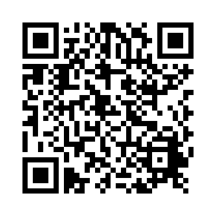

My name is Romany Leach and I am doing this research as part of my counselling psychology training at the University of West of England, Bristol.
Ethical approval code: TBC
Supervised by Dr Nikki Hayfield and Dr Zoe Thomas

