
UNIVERSITY OF EAST LONDON
Department of Psychology and Human Development
School of Childhood and Social Care

ARE YOU A COUNSELLOR OR PSYCHOTHERAPIST?
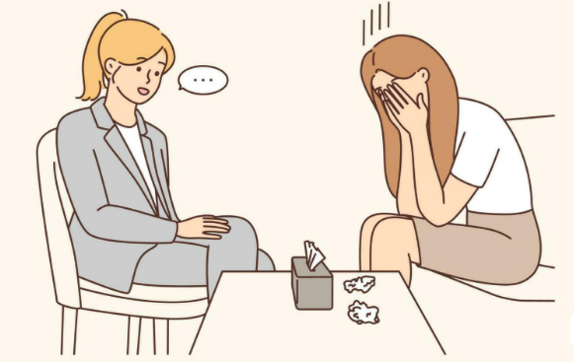
I’m a level 6 student from the University of East London, counselling programme, and conducting a research study to explore therapists’ perspectives on supporting survivors of domestic abuse.

WHO CAN TAKE PART?
- Qualified counsellors or psychotherapists
- Experience working with survivors of domestic abuse

WHAT’S INVOLVED?
- A confidential interview (approx. 45-60 minutes)
- Your insights will contribute to research on therapeutic support

CONFIDENTIALITY
- All information will be anonymised
- Approved by University of East London

INTERESTED?
Contact: Blanche Lubasu
Email: U2605063@uel.ac.uk

