



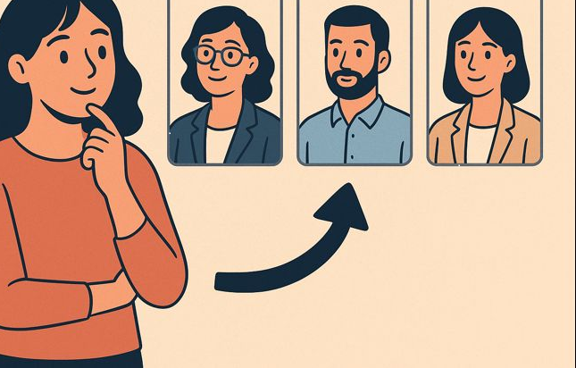


Exploring South Indian Trainee Psychotherapists’ Experiences of Personal Therapy in Training
for

FACE-TO-FACE or REMOTE
INTERVIEWS
For my final year research project as a Masters student in Psychotherapy and Counselling training at University of Warwick
This research explores how South Indian trainee psychotherapists in the UK think about and make decisions when choosing a personal therapist during their training. The study aims to deepen the understanding of personal, cultural, and professional considerations involved in this choice. Interviews will be confidential and anonymised.
Please enquire (see details below) if: -
- You are 18 and over
- You are South Indian trainee psychotherapists or psychotherapeutic counsellors currently in training in the UK
- You have undertaken personal therapy as part of training requirements
- You are recently qualified therapist (within the last 3 years) who have completed personal therapy as part of training
Meghana Badami,
MSc Trainee Psychotherapist


EMAIL: u5583107@live.warwick.ac.uk

