Call for research participants

Are you a trainee or newly qualified psychotherapist or counsellor who identifies as autistic?
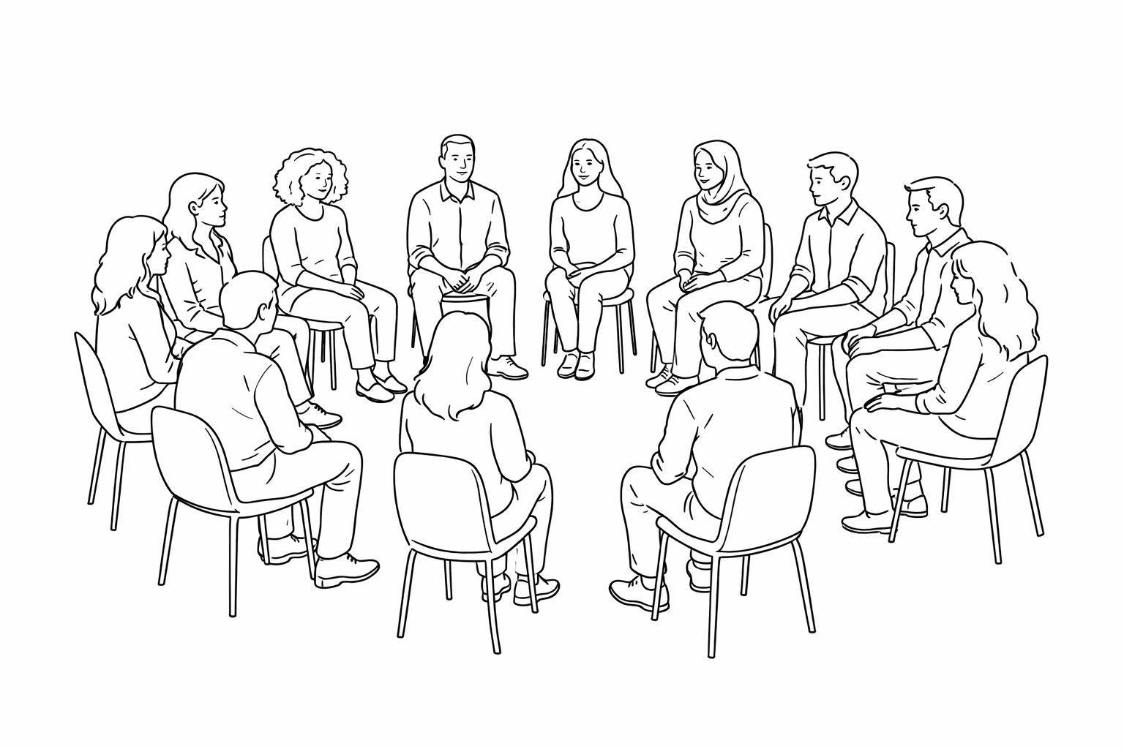
My name is Caroline Horton and I’m an autistic post-grad in my 3rd year of the MSc in Counselling & Psychotherapy at the University of Warwick.
I’m looking to speak with autistic trainees and newly qualified psychotherapists or counsellors about their experiences of Personal Development (PD) groups during their training. (PD groups might be referred to as group process, experiential groups and encounter groups by different institutions.)

Taking part involves a confidential 1:1 Teams interview (60–90 minutes).
- No formal autism diagnosis is needed
- Newly qualified is defined as having qualified within the past 2 years
- Participants’ training should be integrative
- Participants should have participated in a PD group for at least 2 years

If you’re interested in taking part or would like more information, please email me at: caroline.horton@warwick.ac.uk
Interviews will take place across February and March 2026.

Ethical approval for this study has been granted by the University of Warwick.

Thank you for reading, Caroline

