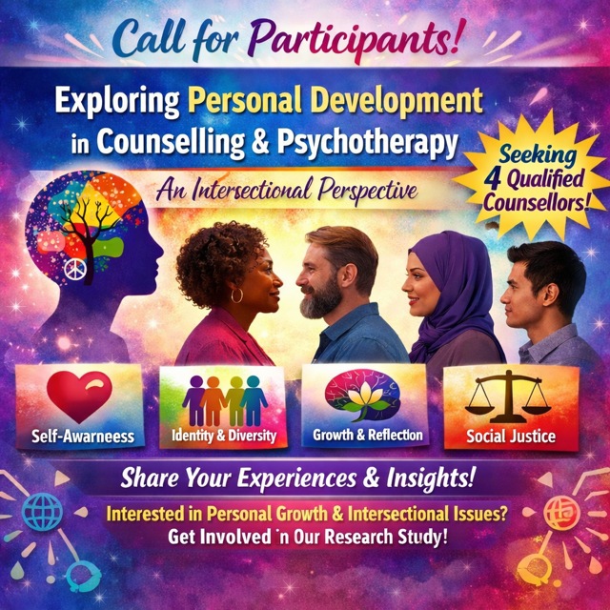

Who am I? My name is Mihaela Luiza Peake, and I am a final-year BA Hons student studying Integrative Counselling at NCC College in Hornchurch.
What is the research project about? I am exploring how qualified counsellors experience and understand personal development in relation to their intersecting identities within professional practice.
Who can take part? I am looking for four qualified counsellors who are registered with the BACP and currently practising in the United Kingdom (UK). Participants need to identify as holding multiple intersecting identities, such as gender, race, class, sexuality, disability, age, or cultural background, and be willing to reflect on how these intersections have influenced their personal and professional development as counsellors.
Exclusion criteria: Counselling students or trainees, anyone under 18, friends, family, current or ex-clients and vulnerable adults.
How will I manage data collection? Participants will each take part in an individual semi-structured interview via Microsoft Teams, lasting no longer than an hour. Participant comfort and well-being are a priority throughout; participants may choose to keep their camera switched off at any time during the interview without any obligation to explain their decision. With participants' consent, interviews will be recorded and subsequently transcribed to ensure accuracy. Data will be analysed using thematic analysis, which allows for flexible and detailed exploration of participants' lived experiences. One week prior to their interview, participants will receive the ten interview questions by email, allowing adequate time for reflection and preparation. All data collection will be fully anonymised, and any identifying information will be treated with strict confidentiality in accordance with GDPR (2018)
Contact details: 19182236@students.ncclondon.ac.uk

