
cc
24
Ethical Framework review
Second Consultation
Impact Assessment on the
Ethical Framework 2026

Copyright information

Ethical Framework Review: Impact Assessment on the Ethical Framework 2026 report is published by the British Association for Counselling and Psychotherapy, BACP House, 15 St John’s Business Park, Lutterworth, Leicestershire, LE17 4HB. T: 01455 883300 E: bacp@bacp.co.uk www.bacp.co.uk BACP is the largest professional organisation for counselling and psychotherapy in the UK, is a company limited by guarantee 2175320 in England and Wales, and a registered charity, 298361.

Copyright © 2026 British Association for Counselling and Psychotherapy. BACP and the BACP logo are registered trade marks of BACP. Permission is granted to reproduce for personal and educational use only. Commercial copying, hiring, and lending are prohibited.

- Purpose
The purpose of an Impact Assessment (IA) is to identify and evaluate the implications of the new Ethical Framework for staff, members, and other key stakeholders. The assessment has been structured around defined thematic areas and stakeholder groups, with each component subject to systematic evaluation.

An IA seeks to establish a clear understanding of the scope, scale, and significance of potential impacts, enabling the transition to be proactively planned and effectively managed. The insights gained from the assessment inform the development of targeted interventions and enablement activities, including communication, training, and implementation support strategies.

A comprehensive and robust IA supports a smooth and well-coordinated transition to the new framework and associated ways of working. While change is not inherently negative, it may necessitate the introduction of appropriate support mechanisms to facilitate successful adaptation and ensure stakeholders are equipped throughout the transition process.

- Methodology
The assessment is organised into defined thematic areas and key stakeholder groups, with each theme, stakeholder combination systematically evaluated in accordance with the scoring scale outlined below.
Impact Ratings
0 | None | No impact is detected. There is no change to current processes, roles, systems or ways of working. No anticipated contention among stakeholders. This also includes scenarios where the impact anticipated is positive.
1 | Low | Minor changes with minimal disruption and little to no new skills or effort required. Little to no resistance is expected. This also includes scenarios where the impact anticipated is positive.
2 | Medium | Noticeable changes requiring some adjustment, learning or modification to how work is performed. The change is likely to create questions and concerns from stakeholders but is unlikely to be overly contentious.
3 | High | Significant changes that substantially alter processes, roles, systems or behaviours. Will require considerable effort to adopt and are likely to encounter resistance or high contention.

- Impact Assessment Summary
The Summary table highlighted the top three priority groups: Individual Members, Professional Conduct team, Course providers. These groups will experience high impact changes and will be the focus of engagement and support activities.
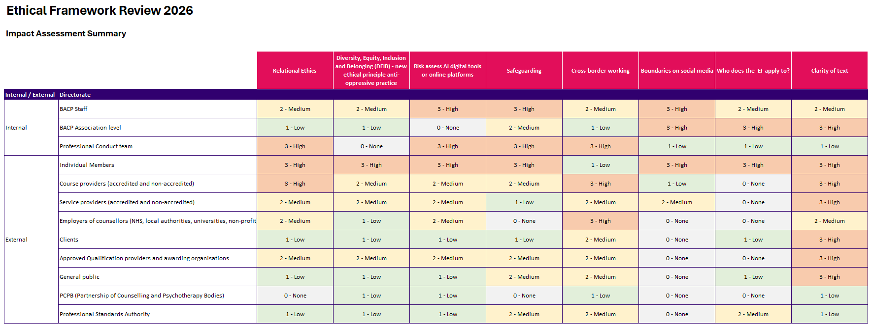

High Impact Stakeholder Groups
Stakeholder Group | Key Areas of High Impact | Overall Impact Level
Individual Members | EDI and belonging, Digital risks, Safeguarding, Boundaries, Applicability of EF | Very High
Professional Conduct team | Digital tools risk, Safeguarding, Cross-border working | High
Course providers (Accredited and Non-accredited) | Relational ethics, Cross-border working, Clarity of text | High

Moderate to High Impact Stakeholder Groups
Stakeholder Group | Key Areas of Impact | Overall Impact Level
BACP Staff | Digital tools risk, Safeguarding, Boundaries | Medium–High
Service Providers (Accredited and Non-accredited) | Relational ethics, Digital risk, Cross-border working | Medium
Approved Qualification Providers and Awarding Organisations | Consistent medium impact across most domains | Medium

Lower Impact Stakeholder Groups
Stakeholder Group | Key Areas of Impact | Overall Impact Level
Clients | Mostly low impact across categories | Low–Medium
General public | Minimal direct impact | Low–Medium
Employers of counsellors (NHS, schools, etc.) | Some engagement related impact | Low–Medium
Partnership of Counselling and Psychotherapy Bodies (PCPB) | Limited impact | Low
Professional Standards Authority (PSA) | Mainly oversight-related | Low

- Enablement and next steps
The impact assessment has informed a structured evaluation of enablement requirements, defined as the activities necessary to equip key stakeholders for the forthcoming changes. These requirements encompass the development of new member resources, as well as the design and delivery of targeted e-learning modules to support effective transition and adoption.

This table summarises which stakeholders are impacted by the Ethical Framework 2026 and the specific training, resources, and support required to enable each group to make the changes effective.

Stakeholder | Impact Level (Overall) | Key Enablement Needs | Core Resources to Provide | Delivery Approach
BACP Staff | Medium–High | New responsibilities (AI, safeguarding, social media, relational ethics) and operational support | • Staff workshops  • Team-specific briefings  • FAQs (esp. AI and member queries)  • Practical toolkits | Structured training programme and team-level enablement
Professional Conduct team | High | Significant process, case handling, and policy interpretation changes | • Bespoke workshops  • Review of PPC procedures  • Case-based learning scenarios | Deep-dive workshops and procedural redesign
BACP Association Leadership (Board/PPC) | Low–Medium | Awareness, governance, reputational oversight | • Executive briefings  • Change summaries  • Governance-level insights | Targeted briefings and papers
Individual Members | High | Major behavioural change across all themes (ethics, AI, safeguarding, boundaries) | • E-learning modules  • Ethics Service and support  • Webinars  • New Resources (documents, videos and checklists | Large-scale digital enablement and ongoing support service
Course Providers (Accredited and Non-accredited) | Medium–High | Curriculum updates and teaching capability | • Train-the-trainer packs  • Curriculum mapping resources  • Teaching resources | Partner-led rollout with training toolkits
Service Providers (Org Members) | Medium | Implementation into service delivery and policies | • Implementation toolkits  • Organisational Resources  • Policy templates | Resource packs and comms
Employers of Counsellors (NHS, universities, etc.) | Medium | Awareness and alignment to practice changes (esp. cross-border, AI) | • Targeted communications  • Briefing materials | Employer-focused comms campaign
Clients | Low–Medium (but high visibility) | Understanding expectations and protections | • Public-facing resources  • ‘What to expect’ resources  • Safeguarding clarity materials | Website and accessible content
Approved Qualification Providers/ Awarding Bodies | Medium | Qualification standards alignment | • Curriculum integration resources  • Communications packs  • Regulatory alignment info | Formal comms and sector engagement
General Public | Low–Medium | Transparency and trust in profession | • Plain English EF summaries  • Awareness content  • Safety and standards messaging | Public website and campaigns
PCPB (Partner Bodies) | Low | Alignment and awareness (esp. AI and cross-border) | • Light-touch comms  • Joint statements updates | Relationship management
Professional Standards Authority | Low–Medium | Accountability, reporting, assurance | • Registrar reporting updates  • Compliance summaries | Formal reporting and assurance mechanisms

5. Delivery overview and timeline
Priority Ethics Essentials resources will be available to support the publication of the 2026 Ethical Framework on Wednesday, 5 August 2026, and further Ethics Essentials and member facing Ethics in Practice resources will be available when 2026 Ethical Framework becomes mandatory from Wednesday, 4 November 2026.

