Research Call for Participants
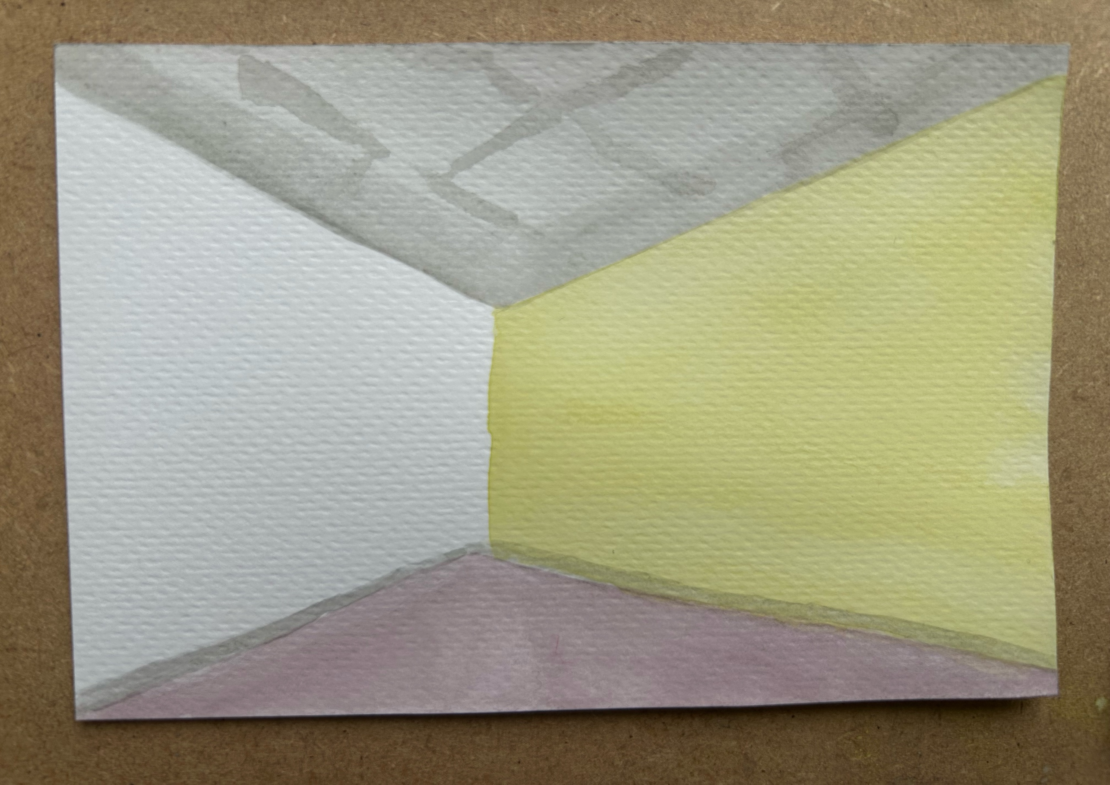
Title of Research: A hermeneutic phenomenological study of counsellor’s experience’s achieving relational depth through creativity.

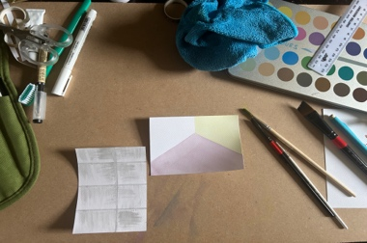
Where creativity meets connection: Exploring relational depth in counselling

Have you experienced moments where creativity deepened your connection with a client or even deepened your relationship with yourself?...
Then your experience could help us to explore creativity and relational depth!
Author: Darcie May Anne Rawlings
Overview of Researcher
As a trainee psychotherapist currently undertaking postgraduate research as part of an MA in psychotherapy studies, I have a strong personal and professional interest in creativity and relational depth, I’m passionate about understanding how these experiences shape therapeutic practice and personal development. I hope to contribute to a richer, more nuanced understanding of the role creativity plays in fostering meaningful therapeutic relationships.
Aim of Research
This research study aims to explore counsellors’ experiences of creativity within both their professional work with clients and their personal lives. It seeks to gain deeper insight into how relational depth is experienced when working creatively with clients, as well as how counsellors encounter relational depth within themselves through creative processes. Additionally, the study will examine the phenomena that emerge through hermeneutic conversations focused on the interplay between creativity and relational depth. By participating, you will contribute to a richer understanding of these experiences within therapeutic practice.
Key Aims Summarised
• To understand the counsellors' experience of creativity in their professional work with clients and in their personal lives
• Gain insight into how relational depth is experienced in the context of working creatively with clients
• Gain insight into how relational depth is experienced in the context of being creative and achieving relational depth within themselves
• To explore what phenomena emerges through hermeneutic conversations focused on relational depth and creativity
Data Collection
Participation in this study involves a hermeneutic conversation conducted in person if possible or online via Microsoft teams lasting up to approximately 60 minutes, where participants may be asked to create a piece of artwork during this conversation. The interviews will be video recorded after gaining your informed consent. Your identity and your contribution will remain confidential throughout the research process and all participant data will be anonymised.
Participant Criteria
• Participants must have 5+ years of experience practicing as a psychotherapist/counsellor
• Participants must be psychotherapist/counsellor who works within a person-centred modality integrates this into their practice
• Participants must have had experiences of reaching relational depth with clients through creative means
• Participants must be registered with a professional body such as BACP, UKCP etc.
If you would like to participate and/or would like further information, please feel free to contact me via email:
Darcie Rawlings - 215063@student.bacoll.ac.uk
Interviews aim to be undertaken late September- October 2026.
Ethical approval for this research project has been granted by Bishop Auckland College.

