
Therapists, we need your perspective
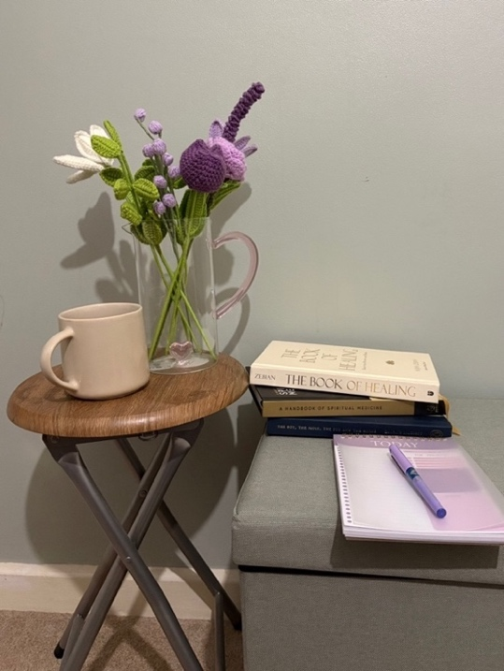
Are you a qualified or trainee therapist who has
engaged in therapy sessions with Muslim clients?
(Counsellor, Psychotherapist, Counselling
or Clinical psychologist, and Creative Art Therapist)

This study explores therapists’ experiences and
perceptions of working with Muslim clients in therapy.

Why participate:
By sharing professional insights, you will contribute to a
deeper understanding of how religious topics, particularly
those relevant to Muslim clients are approached
within therapeutic settings.
Your perspectives will help highlight current
strengths, challenges and gaps in practice.
Who can take part?
- Aged 18+ years and older
- Access to a computer/laptop in a private space
- Qualified and trainee therapists (e.g., counsellors, psychotherapists, counselling psychologists, clinical psychologists, creative art therapists) who have experience of working with at least one Muslim client
- Therapists will need to have completed a minimum of 6 sessions with Muslim clients


What does participation involve?
- A one-to-one online interview held on Microsoft Teams that will last about an hour
- Brief demographic form
- You will be asked about your experiences working with Muslim clients in therapy
- Confidentiality - Your participation will remain confidential and all identifying information will be anonymised





If you would like to take part, please contact:
Tahmeena2.Miah@live.uwe.ac.uk
or scan the QR code

This study has been given favourable opinion by UWE
College of Health, Science and Society Research Ethics Committee reference number 16124558,
and is supervised by Dr Victoria Clarke (Victoria.Clarke@uwe.ac.uk)

This research is being conducted for a Professional Doctorate in Counselling Psychology thesis

