

Student Number: up2558279
RESEARCH PARTICIPANTS NEEDED
Etchics Approval number: 2026-2-3

ARE YOU A LEVEL FIVE TRAINEE COUNSELLOR?

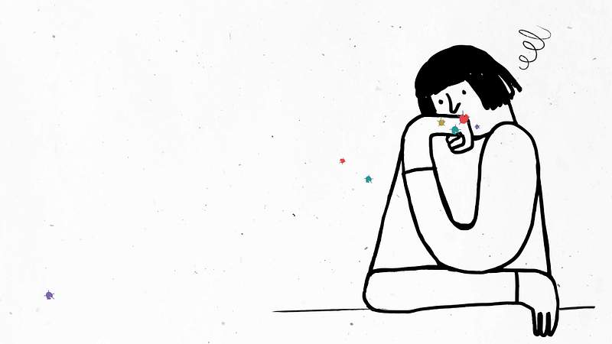
I am conducting a research to examine the relationship in
between self-care practices and burnout levels among level 5 students.
Who can participate?
Level five trainee counsellors
Participation will include a self-care questionnaire
and a burnout inventory which will take 10 minutes all
together.

If you would like to get involved
please scan the QR code which will
take you directly to the questionnaire.
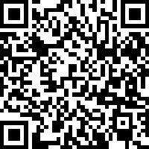

For further information contact me: up2558279@myport.ac.uk

