The Social Response Cycle
Created by Dr. Beverley Costa
www.pasaloproject.org

This information sheet supports The Social Response Cycle online resource for BACP members.

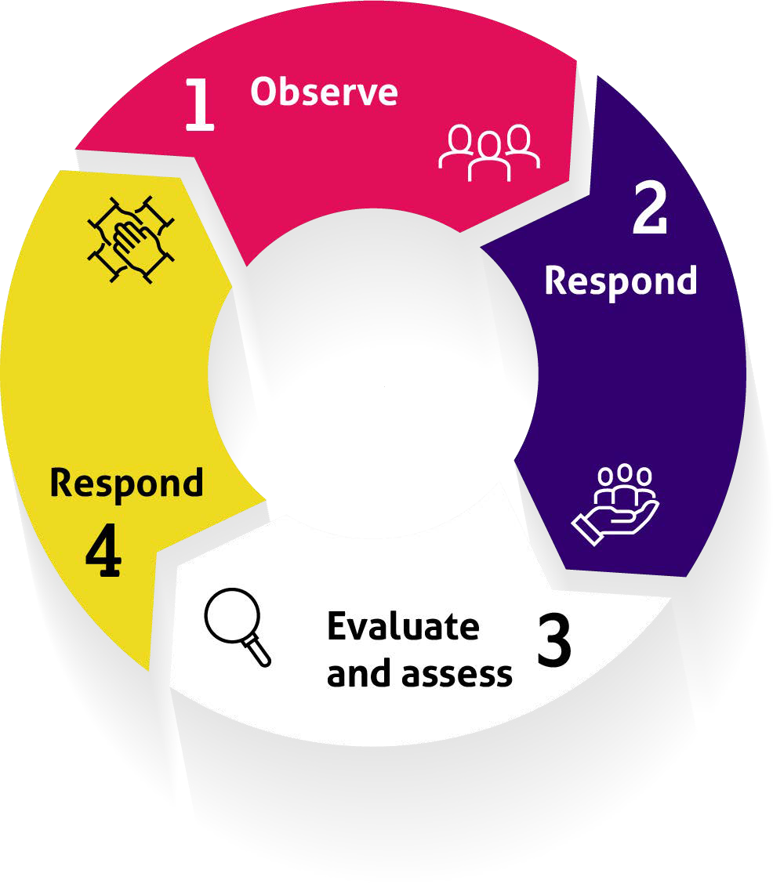

Applying action research principles to address the challenge of putting social justice ideas into action, a model for counsellors and therapists.

Observation

- what have you observed?
- have other people noticed something similar?
- does something need to be done about what you have observed?
- why hasn’t it been done already?
- who will benefit from it?

Response
  - what do you think would be an adequate and appropriate response to your observations?
  - what can you do? What can’t you do? (this could be action, fundraising, conversations, campaigning, service provision etc.)
  - how will people get to know about your project?
  - why will people want to engage with you?

Evaluation
  - what difference will your project make and how will you know if it has made the difference?
  - what can you measure?
  - what can’t you measure?
  - what are three key questions you could ask participants which could give you information about the impact of your intervention?

Response
  - does your intervention or activity need to be adapted in the light of your findings from the evaluation?
  - what will you do next?

Use the whole cycle to think about how you plan to learn from each project and use this learning to shape future projects.

