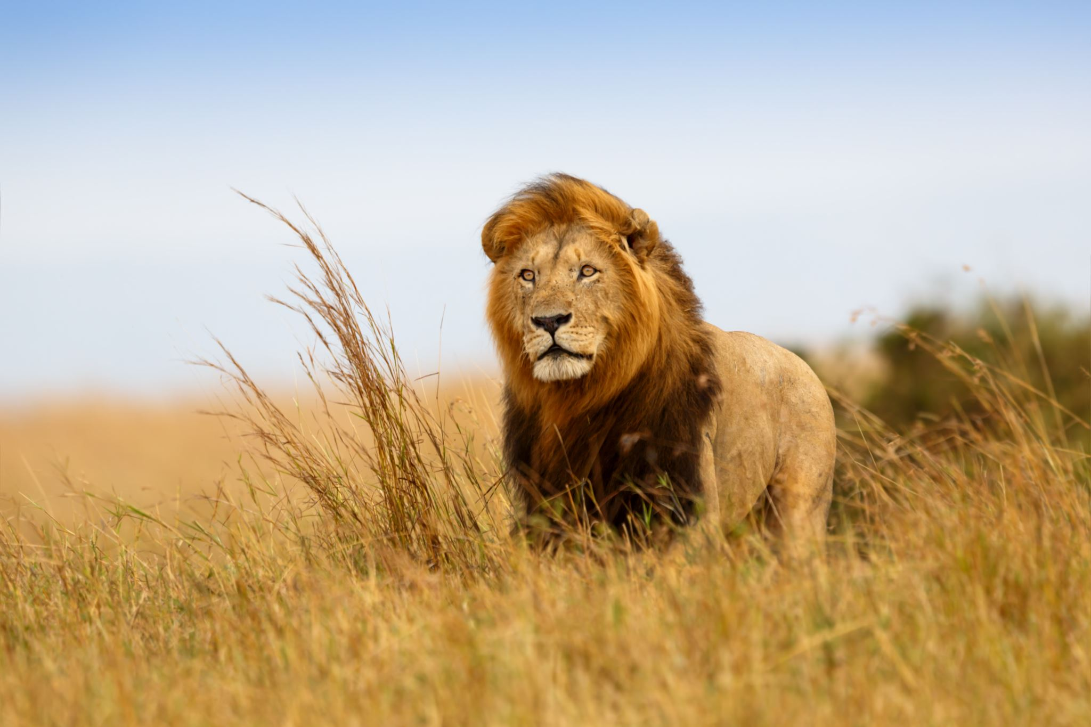
In a world of one’s own: The real Great Escape?

What is the experience of escaping from childhood trauma
into a fictional world?

Have you experienced childhood trauma?
Did you ever use a fictional world to escape from that childhood trauma?
Have you explored your childhood trauma in therapy?
Are you willing to share your experience of escaping from childhood trauma into a fictional world?
- I am looking for research participants who have experienced escaping from childhood trauma into fiction and who are, or have been, in personal therapy for a minimum period of 18 months. This is a qualitative study where the focus is on what you experienced in your escape into fiction. The focus is not on the trauma itself.
- Participants will be either 3rd or 4th Year MSc psychotherapy students and will have addressed their childhood trauma in therapy.
- The study aims to identify and describe the themes, essence and meaning of the experience of escaping from childhood trauma into a fictional world and to uncover any therapeutic implications for practitioners and clients.
I am a 4th year student at The Sherwood Psychotherapy Training Institute (SPTI), and this study is part of my MSc in Integrative Psychotherapy. If you would like more information, or to take part, please email me for a participant information sheet.
- I will arrange a brief phone call to discuss the study process and requirements for informed consent.
- From here an audio recorded semi-structured interview will be arranged, lasting one hour.
Your anonymity will be protected at all times. Research will be conducted in accordance with SPTI, UKCP and BACP ethical guidelines for research and counselling.
Contact details: Pamela Daniels Email: pamela.daniels@spti.net

